1. Introduction in robotics

Robots started in the factories by the need of taking the human repetitive tasks. Now, robots can be found in any domain, like medical, shopping, education, military, mining, research and so on.

According to Harvard University, the most robots design which are designed today, are designed to work by themselves, not working together in a team. [2]

The need of creating robots that work together in a team, take the robots industry to another level, which can allow the realization of more complex and harder task. According to researchers at Carnegie Mellon University, it is easier to build multiple robots for multiple tasks than one robot that can do everything. [3] A team of robots would also be more robust when a robots breaks, because it can be easily changed without affecting the other members of the team. [3]

1.1 Robot communication

Robots language is not similar with human language, they do not speak language like English. Instead, they speak a computer language that allows them to receive and transmit commands. [3] They can share information like their position, the timing for when completing a task (when they must complete it together), to send the next action which is needed to be executed and so on.

One definition of communication can be the following state: “An interaction whereby a signal is generated by an emitter and ‘interpreted’ by a receiver” [5].

The main steps present in all communication area are:

1. *Motivation or reason –* why the message must be sent to the receiver.
2. *Message composition –* what the message should contain (the information that should arrive to the receiver).
3. *Message encoding –* transforming the message in a way that can be transmitted on an specific medium (example: digital data, written data, speech, and so on).
4. *Message transmission –* the delivery of the encoded message, using a specific channel or medium.
5. *Noise sources –* influence the quality if signal propagation from sender to receiver.
6. *Message reception –* the message arrived at receiver and reassembled (if the message was sent on multiple channels, or if the message was splitted in multiple messages).
7. *Message decoding* ­– transform the message in a way that can be understood by the receiver.
8. *Message interpretation –* understating the message and take an action according to this. [6]

One important communication method in robotics is cooperative communication. This cooperative communication is borrowed from nature and animals. The robots reproduce collective behavior of animals in order to realize a task by distributing actions, for example they can reproduce the ants behavior. For finding shortest paths, ants don’t tell each other where to go, but change the environment by placing some pheromone on the way they chose. The ants, follow the most odorous path and leaving their pheromone on this way again, the other ants cooperate and after a short period, the shortest way is stabilized. [4]. Another approach of the cooperative communication is borrowed from animals during conflicts/mating. (de cautat cum anume se poate face chestia asta)

The communication can be categorized in two main categories:

1. Explicit communication.
2. Implicit communication.

Explicit communication refers to messages that tend to influence behavior of others, ex: “Do this”, “Don’t do that” and so on. For technical systems and application, explicit communication is defined to be: a direct, deliberate form of communication [7]. In robotics, this communication defines of that actions that have to express goal or transferring information from one to another [5]. This messages must determine what should be done, when, how and by who. This approach involves intermitted request, status information and update on sensory or model information. [5]

ToDo: de cautat un exemplum ai detaliat despre comunicarea explicita in robotica

Implicit communication refers to things we do without any message received from others. This form of communication involves an action representing as a message itself, rather than a message expressed using explicit message [7]. Implicit communication is defined as communication “through the world”, the “non-verbal communication”.

ToDo: de cautat un exemplum ai detaliat despre comunicarea implicita in robotica

Communication between robots depends on other things, like: communication range, communication topology and communication bandwidth.

*Communication range* is a region in which communication can take place, is the area in which the device can communication with another device in the same region. In robotics, there are three communication range used: none, near and infinite. [6] If the communication range is too small, robot’s can’t communicate, if the communicate range is too high, this means that communication can jam, because every robot has to listen on every message that was sent. [4]

Communication topology is an arrangement of the nodes in the network that can be used for communication between any two nodes in the network[8]. The common communication topology are: broadcast, addressed, tree and graph. [6]

ToDo: de adaugat exemple/poze cu tipurile de topologii

Communication bandwidth is the ability of a system to transmit information. The bandwidth determines the capacity of a given communication channels (maximum number of messages transmitted in one minute or in one second) [9]. In robotics, communication bandwidth can be: high – when the communication is essentially “free”, motion-related – motion and communication costs are about the same, low – communication costs are very high and zero – no communication is available. [6]

1. The project develop by researchers at Carnegie Mellon University is focused on coordinating two robots, CoBot and Baxter. CoBot is specialized in localization and navigation, can autonomously find locations, navigate to them and avoid obstacles [3]. Baxter is designed to perform lightweight monotonous task generally completed by humans. It has arms, vacuum cup gripper and an optional pedestal with wheels, allowing it to be moved around, though it cannot move itself.

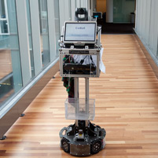

Fig. x. CoBot [10]

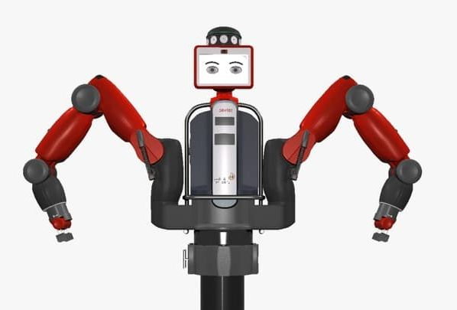

Fig x. Baxter [11]

CoBot can ask a human for assistance if it has any trouble getting its destination, but it doesn’t have arms but can pick up and transport objects with human help [3].

The collaboration between CoBot and Baxter will allow Baxter to manipulate objects and then hand them off to CoBot to deliver them.

For collective systems, a communication plays the role of nervous system in human body.

Swarm robotics is an approach to the coordination of multiple robots as a system which consist of large number of mostly simple physical robots. [1]

[1] – *Swarm robotics* - <https://en.wikipedia.org/wiki/Swarm_robotics>

[2] – *Programmable Robots Swarms -* <https://wyss.harvard.edu/technology/programmable-robot-swarms/>

[3] – *Robots that communicate with each other* - <https://daily.jstor.org/robots-that-communicate-with-each-other/>

[4] – Swarm communication - <http://swarmrobot.org/Communication.html>

[5] - <https://www.cpp.edu/~ftang/courses/CS599-DI/notes/Communication.pdf>

[6]- <https://en.wikipedia.org/wiki/Communication>

[7] - <http://eprints.whiterose.ac.uk/139441/1/frobt_05_00065.pdf>

[8] - <https://www.igi-global.com/dictionary/a-graph-intersection-based-algorithm-to-determine-maximum-lifetime-communication-topologies-for-cognitive-radio-ad-hoc-networks/33949>

[9] - <https://en.m.wikipedia.org/wiki/Bandwidth_(signal_processing)>

[10] - <http://www.cs.cmu.edu/~coral/projects/cobot/>

[11] - <https://blog.rockfordsystems.com/i-cobot/baxter-cobot-from-rethink-robotics/>

Usefull links:

<https://www.hindawi.com/journals/isrn/2013/608164/>

<https://www.bristolroboticslab.com/swarm-robotics>

<http://www.scholarpedia.org/article/Swarm_robotics>